**B1 writing**

**Business letters:**

To whom it may concern,

**Introductie:**

Explain the purpose of your letter/why you are writing this letter:

*I am writing you this letter to inform you…*

*I received your address from a relation…*

*I am writing to apply for the job of fitness instructor, as advertised in THurday’s Courant.*

*I am writing to inform you that the goods we ordered from your company have not been supplied correctly.*

*I am writing with regard to…*

**Body:**

Explain in further detail what you want or need.

*As you can see from my CV….*

*Could you give me some information about…*

**Final paragraph:**

Summarize the most important points of your letter.

**Einde:**

*Thank you for your time and consideration.*

*I would appreciate your immediate attention to this matter.*

*Please feel free to contact me if you have any questions.*

Yours faithfully – als je de naam van degene aan wie je schrijft niet kent.

Yours sincerely – als je de naam van degene aan wie je schrijft wel kent.

Signature

Name company

Your name and position

Bijlagen:

Encl.

**Examples:**

**Offer**

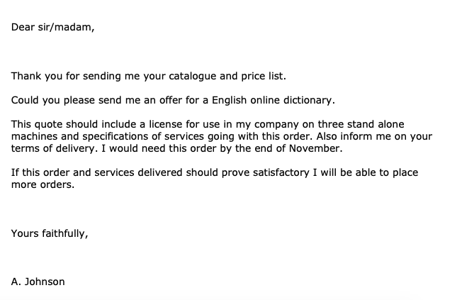

**Order**

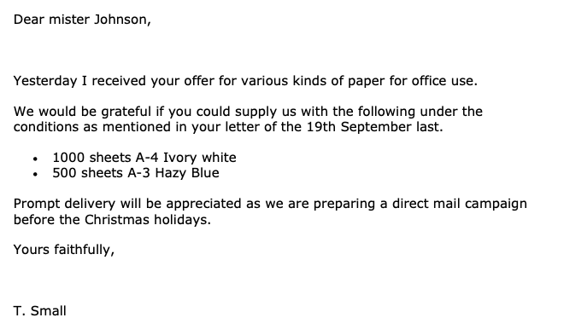

**Complaint**

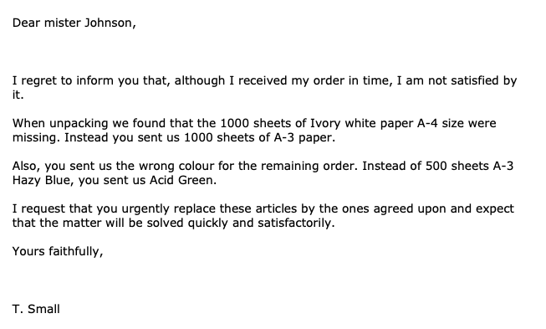

**Apology**

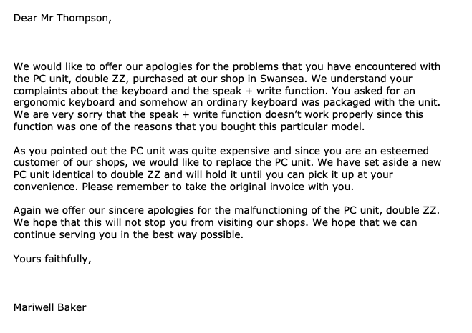

**Job application**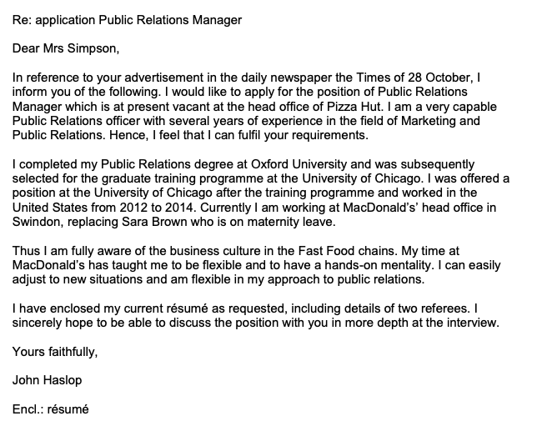

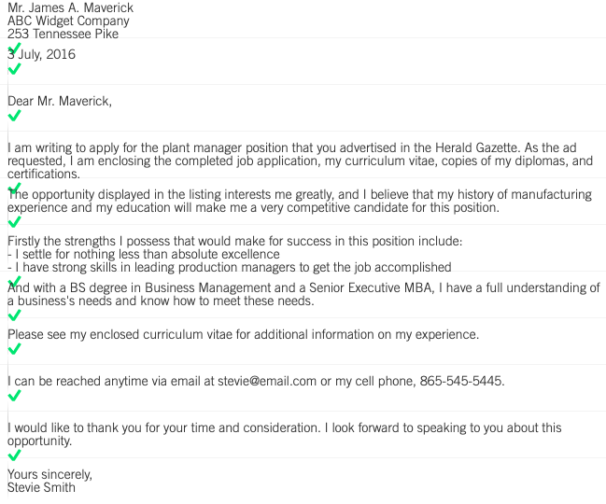

**Tips:**

Start by writing to which job position you are applying. If you have seen a vacancy in a newspaper or on a website you can also put this in your letter.

Useful sentences:

*I saw your advertisement of…*

*I would like to apply to the post of…*

Explain what appeals to you in the job description and why you would be the perfect candidate for the job. Explain in further detail why the job suits you and make reference to the qualities asked in the job advertisement.

Write that you have enclosed your curriculum vitae and that you hope to be invited for a personal interview:

*I am more than willing to provide further details in an interview.*

*I look forward to hearing from you.*

*Please find enclosed my curriculum vitae.*

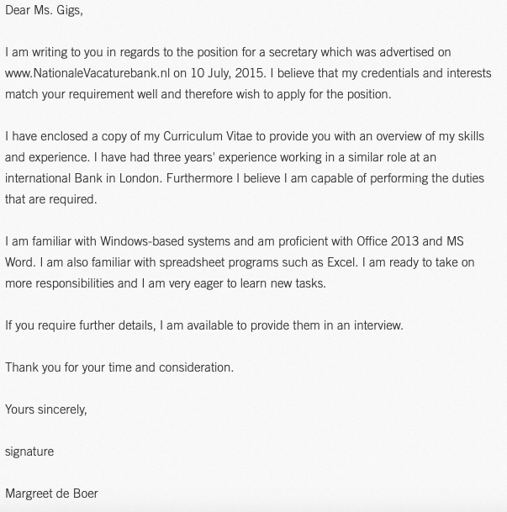

**Curriculum Vitae**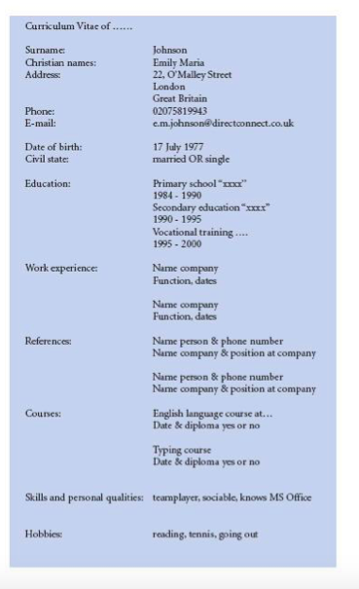

**Cancellation**

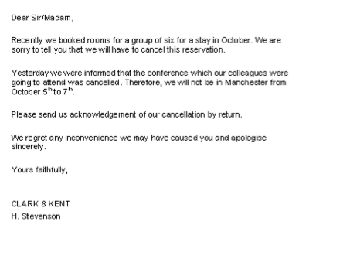

**Report:**

* Factual information
* Reasons for taking action
* Formal writing style